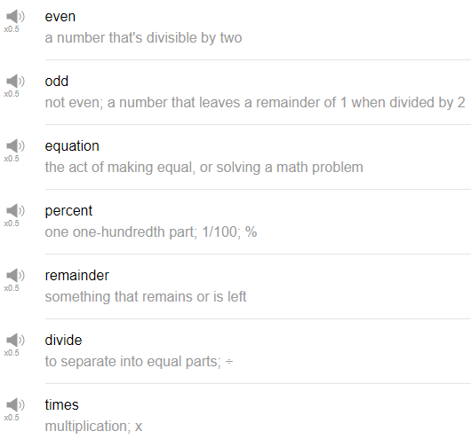

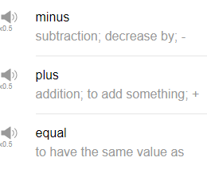

|  |
| --- |
| Hi, everybody! Welcome back to Top Words. My name is Alisha and today we're going to be talking about 10 must know math word. So let's go! |
| 1. Plus. |
| The first word is plus, you might have this + sign on your keyboard, you probably do, it means to add something. So like, one plus one equals two. It's an addition related phrase, plus. |
| 2. Minus. |
| The next one, the opposite of plus is the - sign. So in this case, two minus one equals one. So it's a subtraction. That's related to subtraction, taking away something, minus. |
| 3. Times. |
| Ok, the next one is times, we use for multiplication, so it's represented by an x symbol. So 2 times 2 equals 4. We use x. 2 x 2 equals 4, it's a multiplication related word. I wonder why we use x. 2 x 2. |
| 4. Divided. |
| Divided as the verb, so 2/2 equals 1, for example. Divided by is that dot line dot symbol. 2/2 equals 1. You can use "divided by", is the expression, two divided by... |
| 5. Equal. |
| Equal or equals, we use this before we present the solution to a math problem, so 2 times 2 equals, with an s, equals, it equals four, for example. You can also use equal to show that two things have the same value, two is equal to two. This value is equal to that value, that's another way that you can use the word equal. |
| 6. Equation. |
| The next math word is equation. Equation, so up until now we've been talking about a part of an equation but the whole math problem everything there is called the equation, so the process that you need to do in order to solve an equation. An equation is something that you do to solve a problem. This this part of the equation, this part is the solution. The ending the result is the solution. The problem is called the equation, the process, the math process to find a solution. |
| 7. Percent. |
| Percent, this is a very useful word you can use, of course, when doing math or maths problems, but you can also use this when shopping, for example. So a sale is five percent off, ten percent off, it represents a discount. You can also use percent to describe effort levels, for example, a sports team coach might tell his team, I need you to work at a hundred percent today. So it's used to express the level of something, but it can also be used in sales and in math related terms. |
| 8. Remainder. |
| The next word is remainder. Remainder is used when doing a division, it means, remainder means something that is left over. So when doing division, when doing division problems, sometimes there's a problem or an equation that results in a number that is not round, or a number that is not whole. So for example, 1.2 might be a solution to a math remainder there, that's what's left over. So it's not a whole number but there's something, a little bit, that's left, that's remaining, that's called the remainder, something that's left over. |
| 9. Even. |
| The word even represents numbers like two, four, six, eight, ten, twelve, we consider those numbers even, they end in a 2, 4, 6, 8, or 0. Those are the even numbers. |
| 10.Odd. |
| So the next word is odd, which represents the numbers that are not even. 1, 3, 5, 7, and 9, any number that ends in one, three, five, seven, or nine is called an odd number. Anything that ends in two, four, six, eight, or zero is an even number. |
| Alright, so those are 10 math related words that are actually quite useful, you can use them to talk about, of course, math equations, but they're also useful in, perhaps, in some business situations and when shopping. So give them a try. Thanks very much for watching this episode of Top Words, and we will see you again soon. Bye! |